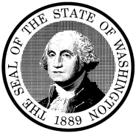

Superior Court of Washington
County of Kitsap

SUPERIOR COURT FOR THE STATE OF WASHINGTON
IN AND FOR KITSAP COUNTY

In re the Guardianship of : | No.  ORDER RE GUARDIAN AD LITEM FEES

The Court finds that the Guardian ad Litem fees herein are reasonable and should be granted.

ORDER
IT IS HEREBY ORDERED that fees in the amount of $____________ and costs in the amount of $____________ shall be paid to __________________________________ by Kitsap County, Washington, for services in the above cited case.

Dated: __________________, 20____ ___________________________________
JUDGE/COURT COMMISSIONER

Presented By:

________________________________

Attached is Affidavit of Fees.

